Robo Soccer
1.Chassis
Chassis length formula
Chassis length = motor length * Wheel Diameter + battery Space
Chassis Width Formula
Width =wheel to wheel +1-2cm
Tentative calculation for wheel diameter motor, RPM, linear speed
Linear speed(m/s) =RPM *pi*wheel-diameter/60
Example: -
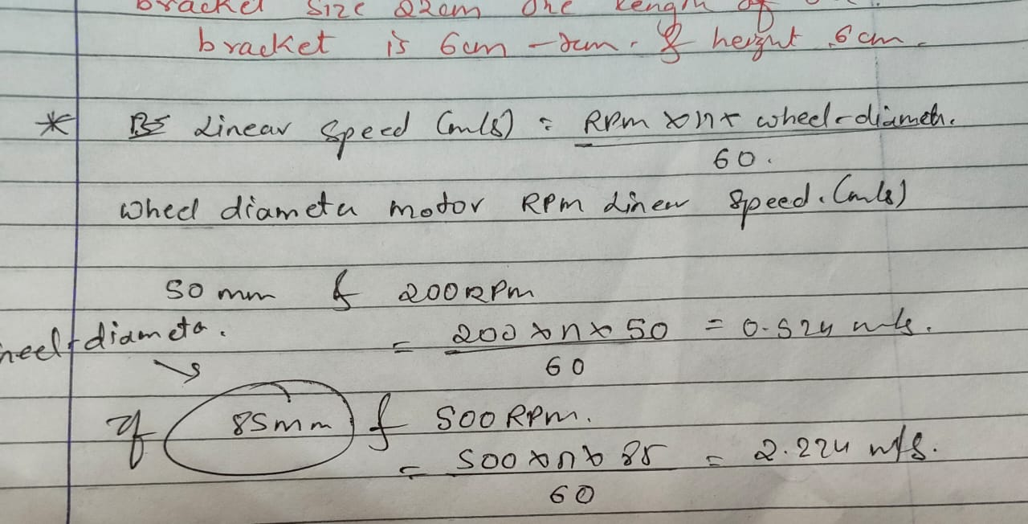
With setup (37GB,500 RPM ,85 mm wheel)
Speed =approx. 2.224m/s
2. Recommended Motor Type & Motor Drive
37 GB gear DC Motor-500 RPM
Why 37 GB gear DC motor?
A 37GB gear motor is very commonly used in robotics because it gives a perfect balance
1.High Torque
The “GB” stands for Gear Box.
The gearbox increases torque — which means your robot can:
- Move smoothly even on uneven surfaces
2. Compact Size
37GB motors are small but powerful.
- 37mm diameter
- Easy to mount
- Not too heavy → good for speed + endurance
3.Durable & Metal Gearbox
The gears are metal, so they won’t break easily during load or collision.
4. Wide Voltage Options
You can get them in 6V, 12V, or 24V versions.
This gives flexibility for battery selection and speed requirement.
5. Many RPM Choices
You can choose the gearbox ratio depending on what your robot needs:
RPM | Good For
10–60 RPM | Very high torque lifting bots
100–300 RPM | Combat robots, pushing
500+ RPM | Fast racing bots
So, one motor model fits different robot types!
6. Cheaper Than Brushless Motors
Good performance at low cost → best for students and competitions.
Reference Link: - https://www.youtube.com/watch?v=gxoFwbduTOc
Recommended Motor Drive/ESCs: -
It is controlled using a motor drive (BTS7960, Cytron)
Why you should use BTS7960?
1. High Current Capacity
BTS7960 can handle 43A peak current.
Your 37GB motor may draw 5-10A stall current, so BTS7960 has more than enough margin → safe, strong, reliable.

2. H-Bridge Built-In (Forward + Reverse) It has a complete H-bridge circuit, so your robot can:
Move Forward
Move Backward
Stop
Turn, by controlling motors independently
3. Control System
Transmitter & Receiver

